**Git Lab**

**Objective:**

To understand and demonstrate the use of Git commands for basic source control including git init, status, add, commit and push using terminal.

**Steps:**

1. Initialize a Git Repository:

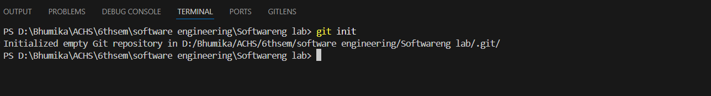

A .git folder is created which tracks changes:

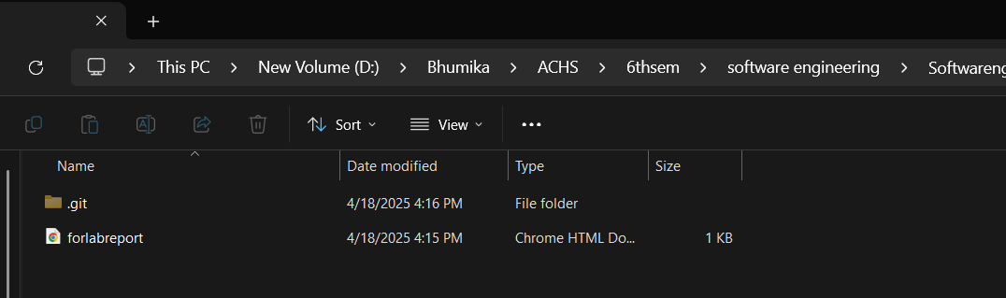

1. Check Git Status

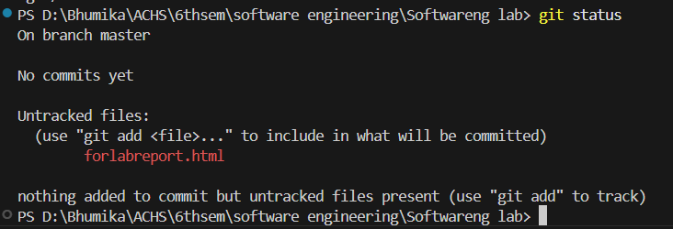

1. Create and Add a File:

After creating “forlabreport”.html file;



1. Commit Changes

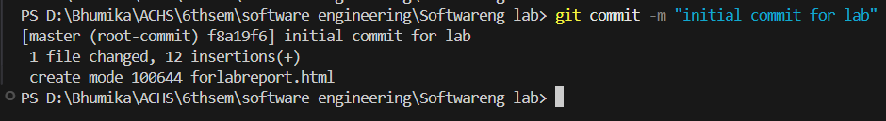

1. Create Remote Repository (GitHub)

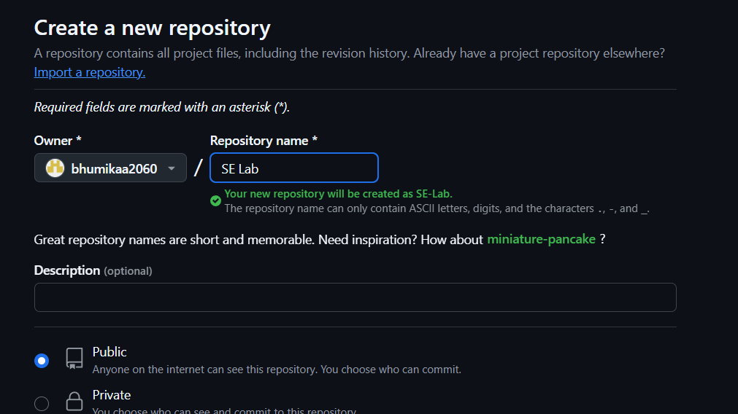

1. Add Remote URL



1. Push to Remote Repository

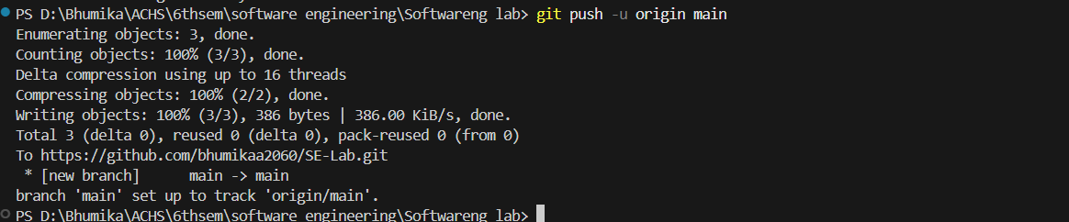

**Conclusion**

The lab demonstrated the essential Git commands used in version control through terminal. Using git init, status, add, commit and push allows effective tracking and management of source code changes in a collaborative environment. GitHub integration ensures secure backup and team collaboration.